Grove - Temperature and Humidity Sensor Pro

|  |
| --- |
| **Contents**   [[hide](javascript:toggleToc())]   * [1 Introduction](http://www.seeedstudio.com/wiki/Grove_-_Temperature_and_Humidity_Sensor_Pro#Introduction) * [2 Features](http://www.seeedstudio.com/wiki/Grove_-_Temperature_and_Humidity_Sensor_Pro#Features) * [3 Application Ideas](http://www.seeedstudio.com/wiki/Grove_-_Temperature_and_Humidity_Sensor_Pro#Application_Ideas) * [4 Cautions](http://www.seeedstudio.com/wiki/Grove_-_Temperature_and_Humidity_Sensor_Pro#Cautions) * [5 Specification](http://www.seeedstudio.com/wiki/Grove_-_Temperature_and_Humidity_Sensor_Pro#Specification) * [6 Usage](http://www.seeedstudio.com/wiki/Grove_-_Temperature_and_Humidity_Sensor_Pro#Usage) * [7 Resources](http://www.seeedstudio.com/wiki/Grove_-_Temperature_and_Humidity_Sensor_Pro#Resources) * [8 Support](http://www.seeedstudio.com/wiki/Grove_-_Temperature_and_Humidity_Sensor_Pro#Support) |

Introduction

Go pro in temperature and relative humidity measuremnt applications with this Grove gadget. This is a powerful sister version of our Grove - Temperature and Humidity Sensor. It has more complete and accurate performance than the basic version. The detecting range of this sensor is 5% RH - 99% RH, and -40°C - 80°C. And its accuracy satisfyingly reaches up to 2% RH and 0.5°C. A professional choice for applications that have relatively strict requirements.   
Model:[SEN51035P](http://www.seeedstudio.com/depot/grove-temperaturehumidity-sensor-pro-p-838.html?cPath=144_147)

[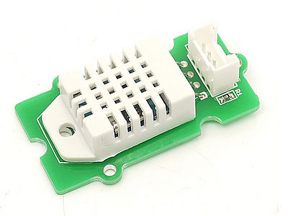](http://www.seeedstudio.com/wiki/File:Temp_humi_pro.jpg)

Features

* Wide detecting range
* High accuarcy
* Ultra low power consumption

Application Ideas

* Professinial personal weather station
* Humidity regulator

Cautions

The warnings and wrong operations possible cause dangerous.

Specification

|  |  |  |  |  |  |
| --- | --- | --- | --- | --- | --- |
| **Items** | **Conditions** | **Min** | **Norm** | **Max** | **Unit** |
| VCC | - | 3.3 | - | 6 | Volts |
| Measuring Current Supply | - | 1 | - | 1.5 | mA |
| Standby Current Supply | - | 40 | - | 50 | uA |
| Measuring Range | Humidity | 5% | - | 99% | RH |
| Temperature | -40 | - | 80 | °C |
| Accuracy | Humidity | - | - | ±2% | RH |
| Temperature | - | - | ±0.5 | °C |
| Resolution | Humidity | - | - | 0.1% | RH |
| Temperature | - | - | 0.1 | °C |
| Repeatability | Humidity | - | - | ±0.3% | RH |
| Temperature | - | - | ±0.2 | °C |
| Long-term Stability | - | - | - | ±0.5% | RH/year |
| Signal Collecting Period | - | - | 2 | - | S |
| Respond Time | 1/e(63%) | 6 | - | 20 | S |

Usage

1. Connect the Temperature and Humidity Sensor Pro to analog port A0 of [Grove - Base Shield](http://www.seeedstudio.com/wiki/Grove_-_Base_Shield). Then plug Grove - Base Shield into Arduino and connect Arduino to PC using a USB cable.  
[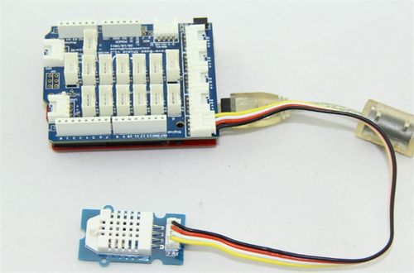](http://www.seeedstudio.com/wiki/File:Grove_-_Temperature_and_Humidity_Sensor_Pro.jpg)  
2. Download [File:Humidity_Temperature_Sensor library](http://www.seeedstudio.com/wiki/File:Humidity_Temperature_Sensor.zip); Unzip and put it in the libraries file of Arduino IDE by the path: ..\arduino-1.0\libraries;   
3. Restart the Arduino IDE. Open “ DHTtester” example via the path: File --> Examples --> Humidity_Temperature_Sensor --> DHTtester. Through this demo, we can read the temperature and relative humidity information of the environment.  
  
[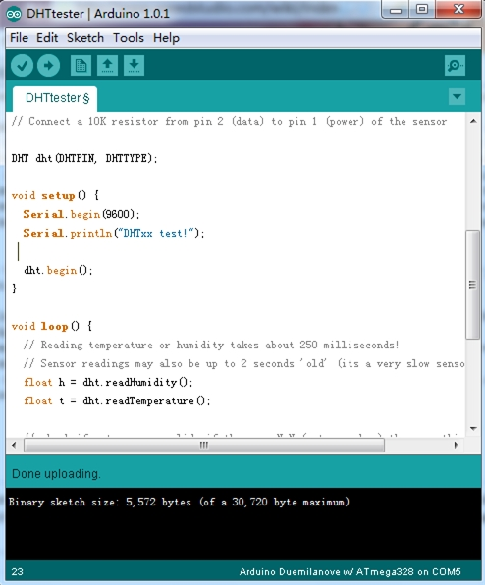](http://www.seeedstudio.com/wiki/File:DHTtester_code.jpg)  
  
**Note:**

This Grove - Temperature and Humidity Sensor and our another product [Grove-Temperature and Humidity Sensor](http://www.seeedstudio.com/wiki/Grove_-_Temperature_and_Humidity_Sensor) are sharing this library. No matter which product you are using, make sure you make the definition line of the sensor of your board into effect and comment out the definition lines of other specs. For example, the sensor we use on Grove - Temperature and Humidity Sensor Pro is DHT 22. So the definition part of the sensor spec should be:

//#define DHTTYPE DHT11 // DHT 11

#define DHTTYPE DHT22 // DHT 22 (AM2302)

//#define DHTTYPE DHT21 // DHT 21 (AM2301)or

4. Upload it into your Arduino board. If you do not know how to upload, please click [here](http://www.seeedstudio.com/wiki/Upload_Code).  
5. Open the serial monitor, you can see the score as below:  
[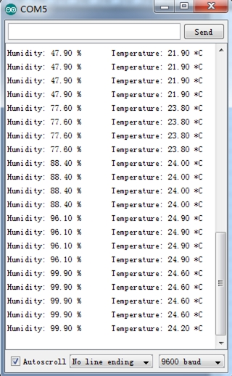](http://www.seeedstudio.com/wiki/File:DHT_Test_Score.jpg)

Resources

* [File:Temp Humi Pro eagle files.zip](http://www.seeedstudio.com/wiki/File:Temp_Humi_Pro_eagle_files.zip)
* [File:Humidity_Temperature_Sensor library](http://www.seeedstudio.com/wiki/File:Humidity_Temperature_Sensor.zip)